Capstone Project - The Battle of Neighborhoods

**Title: Where should a coffee shop be opened in Hong Kong**

* 1. **Introduction**

Hong Kong is a multicultural city where a lot of different kinds of restaurants can be found. For this project, we are going to explore what is the best district for a coffee shop to be opened.

* 1. **Discussion**

In Hong Kong, there are a totally 18 districts. Each district has its own special features. For example, in the district where my home is, loads of restaurants and households can be found but commercial buildings are not found. If someone is going to open a coffee shop, what is the best location?

* 1. **Target Audience**

This report is targeted to people who are interested in investing a coffee shop in Hong Kong.

1. **Data**

Location data from Foursquare will be used to obtain the most popular types of restaurants in different districts. Also, family income data will also be used to see how affordable are people in Hong Kong.

1. **Methodology**

The family income data from the Home Affairs Department of Hong Kong is used in this work. The data comes from the census conducted in 2016. Then the district boundary data is collected from the Home Affairs Department of Hong Kong. It is used to separate Hong Kong into the 18 districts in the map. The Folium package is used to generate a choropleth map to show the income levels in different districts in Hong Kong.

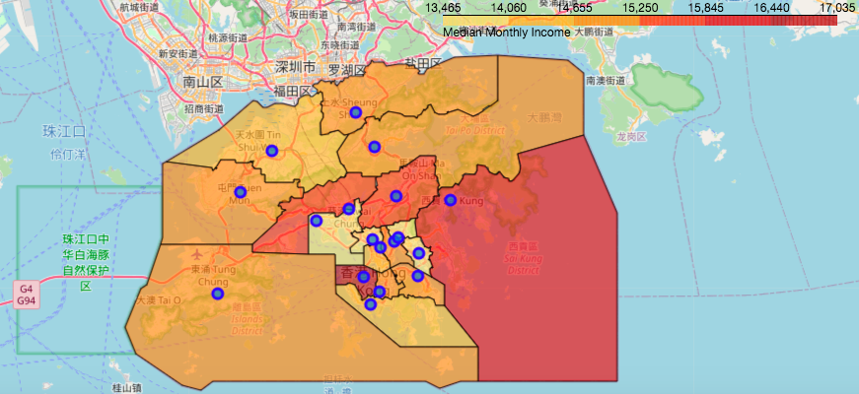

Fig. 1 Choropleth map of Hong Kong showing the income level of different district

The most popular venues of different districts are collected from Foursquare.

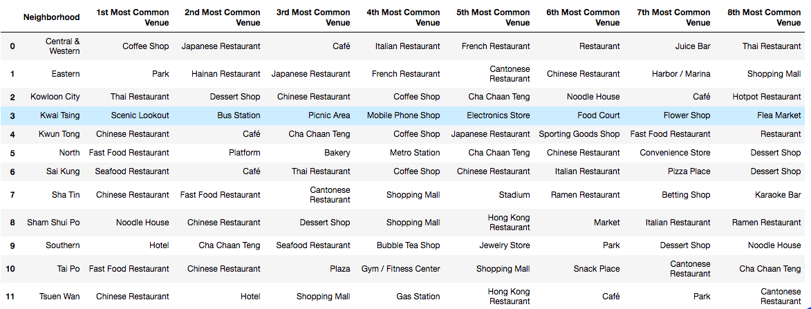

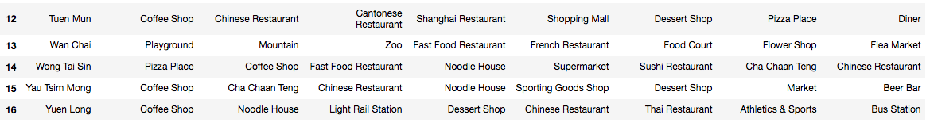

Table 1 The 8 most common venues in different districts of Hong Kong

The number of coffee shops in the districts where coffee shop being the most common venue is found out from the Foursquare data and plotted as a bar chart.

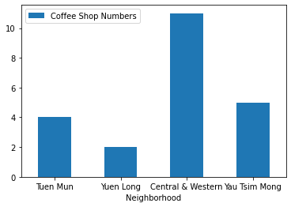

Fig. 2 Bar chart of the number of coffee shops in the four neighborhood

* 1. **Result**

As shown in the choropleth map, the district with the highest income is Central and Western district, followed by the Sai Kung district. Central and Western district is one of the CBD of Hong Kong and you can find a lot of cozy private apartments and houses there. Sai Kung district is kind of a newly developed district where private estates are dominating. Among the 18 districts, coffee shops are the most popular type of venue in Central and Western, Tuen Mun, Yau Tsim Mong and Yuen Long. Among the four districts, Central and Western district has the most number of coffee shops.

* 1. **Discussion**

As seen from Table 1, coffee shops are the most popular type of venue in Central and Western, Tuen Mun, Yau Tsim Mong and Yuen Long. If we put these four districts in descending order of their median income, the order would be Central and Western, Yau Tsim Mong, Tuen Mun and finally Yuen Long. As mentioned above, Central and Western district is one of the CBD so lots of commercial buildings can be found. Yau Tsim Mong is a district where some commercial buildings and shopping malls can be found, while Tuen Mun and Yuen Long are household districts where a few commercial buildings can be found. Given that the income levels are quite different among these four districts, it is obvious that the coffee shops in these districts target people of different backgrounds.

For coffee shops in Central and Western district, as commercial buildings are dominating, businessmen with higher salary are their target customers. For their counterparts in Tuen Mun or Yuen Long, they may target people like housewives and students who mainly stay within their neighbourhoods. Thus, if someone is going to open a coffee shop in Hong Kong, he should decide whether he wants to open a cozy, higher-class coffee shop or a down-to-earth coffee shop first.

**4. Conclusion**

By collecting data about the family income and the popularity of coffee shops in different Hong Kong’s districts, we can conclude that people who lives in Central and Western district, Yau Tsim Mong, Tuen Mun and Yuen Long love coffee shops the most. When we compare the income level of these districts, we can find that the coffee shops have quite different targeting customers. If someone would like to open a coffee shop in Hong Kong, I would suggest him first decide what level of a coffee shop to open. If he would like to open a more cozy one, Central and Western district maybe a good idea as people living there are more affordable. If he would like a down-to-earth one, I would suggest Yuen Long because the number of coffee shops in Yuen Long is less than that in Tuen Mun so that less competition is expected.